**Undergraduate Work Placement Report 2021**

**Title Page**

**School of Computer Science & Information Technology**

**University College Cork**

|  |  |
| --- | --- |
| **Student Name** | Nathan Crowley |
| **Student Number** | 118429092 |
| **Company Name** | Clearstream Global Securities Services Ltd |
| **Workplace Mentor** | Colum O’Riordan & Martin Allen |
| **Workplaces Mentor Role** | IFS IT Vestima Prime Manager |
| **Workplace Mentor Signature** |  |
| **Academic Mentor** | Frank Boehme |

**1 Summary**

The Work Placement Programme began on 22/03/2021 and concluded on 27/08/2021.The Work Placement took place with Clearstream Global Securities Services Ltd, based in Albert Quay, Co. Cork. Clearstream are a post-trade services provider owned by Deutsche Börse AG.

The work was carried out in the IFS IT Vestima Prime department. The role given was IT intern – developer. The IFS IT Vestima Prime department was comprised of 10-12 employees with Colum O’Riordan acting as manager and Martin Allen acting as development manager.

The work week consisted of Vestima Prime daily catch-up meetings at 9.30 am, which revolved around the daily tasks of the development team as well as any issues that arose since the most recent catch-up. The work week consisted of 38.75 hours broken down to Monday to Friday usually 9.00 am – 5.30 pm. The employment period consisted of both large projects as well as small daily tasks. The smaller daily tasks consisted of meetings, training, code fixes, etc. The larger tasks consisted of five projects:

1. SQL JCCS Cutovers with Java & XML implementation.
2. Java Servlet & JSP file uploader to JCCS’s Mr T.
3. JIRA internal ticketing system tasks.
4. Document Management System research.
5. Proof of Concept regarding Document Management System research.

The Work Placement period allowed for the acquisition of many new skills as well as the enhancement of prior skills. The first two weeks consisted of company structure and business operation presentations. The presentations taught fundamental business terminology such as Mutual funds & Hedge funds, along with their differences and key features. The internal CATS system was demonstrated, and the process of logging hours was shown. The next stage comprised of setup with the Vestima Prime team and internal systems. The daily catch-up process was shown along with being exposed to development cycles, which improved communication skills working with a small development team of 10-12 employees. The months that followed improved technical skills of tools such as Java programming language, SQL, XML, SOAP UI testing, DDL/DML checks for cutovers, JIRA, GitHub commit and pull process, Java Servlet/JSP development, etc.

**2 The Company**

Clearstream Global Securities Services Ltd are a post-trade services provider owned by Deutsche Börse AG. Clearstream provides settlement and custody as well as other related services for securities across all asset classes. Clearstream maintains around 2,500 customers in over 110 countries. The customer base extends over 58 domestic markets, with over 300,000 domestic and internationally traded bonds, equities, and investment funds. Clearstream has offices in Cork, Luxembourg, Prague, and Singapore. The Cork office has some 480 employees in all departments.

Clearstream aims to be a ‘one-stop-shop’ that offers clients both Hedge & Mutual funds operations, offering everything to the client as one package. Hedge and Mutual funds are handled separately by Clearstream, Vestima Prime handles the Hedge Funds, with Vestima Plus handling the Mutual Funds. The operational teams are the Client team, Trading, Data Management, Corporate Action, Reconciliation & Incident Management, Core Client services, Investment Funds transfer, etc.

Each Clearstream department has a ‘Head of Unit’, followed by a ‘Team Manager’ with sub managers such as ‘Development manager’. The IFS Vestima Prime development comprises of 10-12 employees.

The business flow consists of six steps:

1. Client places an order.
2. Clearstream (CCS) processes the order and creates an ‘Order to Fund’.
3. The Order is Accepted or Rejected by the Fund Administrator.
4. Clearstream informs the client the order has been Accepted or Rejected.
5. Fund Administrator passes a ‘Contract Note’ to Clearstream.
6. Clearstream confirms the details of the ‘Contract Note’ and confirms the order to the client.

Clearstream (“the Custodian”) charges a fee to the clients who have holdings (“a Position”) on the books. Clearstream has a 2020 revenue of €2.936 billion, with net profits of €1.105 billion. With a share price of €149.90 as of 25/08/2021.

**3 My Work Placement**

The Work Placement Programme began on the 22/03/2021, in the Albert Quay office, with a tour of the office space. Following the tour there was HR presentations on Clearstream’s business operations, fundamental financial terms such as Funds, Mutual/Hedge Funds, Clearstream’s Operational Teams, etc. The presentations improved company knowledge, financial knowledge and gave in sighted into the business. Meetings took place with IFS IT Vestima Prime manager, Colum O’Riordan, and Head of Unit, Peter Carroll. The development team setup process began, this involved downloading and installing internal applications. The ‘SafeNet MoiblePASS’ credentials, used to generate access tokens to the Virtual Desktop (VDI), were created. The VDI is used for internal development of products such as JCCS,etc. The setup process enhanced knowledge of internal terminology such as Virtual Machines (VM’s) referred to as VDI. The first stand-up meeting with the team took place on Wednesday 24/03/2021. The first ‘Friday Fun Quiz’ took place 26/03/2021, this is used to improve team building inside the development team. The first meeting with Martin, development manager, took place on the 26/03/2021. The internal CATS system for logging hours worked was first used.

The second week began with a Microsoft teams meeting with Colum and Martin. The outline of the 6-month work period was presented. The development team uses Java & Oracle for back-end with React & Angular used on front-end. An email was sent to the University College Cork Academic Mentor as introduction with company and job details. Work continued on the installation & set-up process. A ‘new starters & interns’ meeting took place at 2.30pm 01/04/2021. This week presented the knowledge of Jboss servers and how to download & install. More meetings took place with the development manager. There was a presentation on Clearstream’s business operations along with information on common clients of the business. The Cork Clearstream office mainly operates in Hedge Fund post trade services, with emphasis on the transfer of securities. The presentation showcased the operations of JCCS looking at both front-end and back-end. A flow-diagram was shown demonstrating Clearstream’s business model and taught how the company works and the different inner process.

The third week commenced with ‘Stock Market’ presentation at 3pm on 06/04/2021. The presentation covered information on Clearstream’s parent company, Deutsche Boerse Group (DGB), along with financial terminology. Deutsche Boerse Group is one of the largest finanical operators in the world, with over 9,000 employees as of 2021, offering a diverse set of servies such as ‘Pre-IPO’, ‘Trading’, ‘Post-Trade’, etc with the Post-Trade services offered by Clearstream. Daily stand-up meetins with the development team continued. Meeting took place with development manager on 08/04/2021 regaring cutovers. Cutover is a change of data in the database. Oracle SQL developer was demonstrated and how to create SQL cutover scripts. Improved communication skills participating in the weekly quiz.

The fourth week compromised of SQL cutover development. First task was to create SQL script to update the database ‘LK_EMAIL_TEMPLATES’ of automated internal emails. The requirement was to add to each automated email a placeholder for confidential text, such as [ConfidentialText]. Next was to update JCCS Java & and XML code. The Java code is used to retieve a string from the XML and replace the placeholder with a given string. Getters and Setters were created inside the Java code as well as adding @BeanPropertySetters to link the XML. Performed DDL/DML checks using SOAP UI to test the cutovers had not altered other developers code. Transaction elecments were added to the SQL script, only allowing data change when cutover is fully executed. Imporved knowledge of cutovers and how to create SQL scripts inside Oracle developer. How to execute cutover script eeffectivley and not interupt other development work.

**3 My Work Placement**

The second month of work placement began on 19/04/2021. Following the cutover task being completed, the process for committing to the ‘Dev’ remote repository using GitHub push & shelf. GitHub shelf creates a local commit with your changes, along with the commit message ‘SHELF’. Continued daily stand-ups with the development team. The SQL cutover scripts along with Java & XML changes to JCCS were committed to ‘Dev’. There was a #300 error message during the process of running the cutovers. The #300 error message was solved with instructions inside the ‘readme_DBPrepSteps.txt’ inside ‘/local/jccsbin/JCCS_CUTOVER’. Tasked with arranging and generating a general knowledge quiz for the team’s weekly Friday fun. The weekly quiz enabled good interaction with the team and was a great way to get involved virtually with team members.

Following the completion of the cutover tasks, a meeting was set up with the development manager regarding the next project to be completed. The research was completed on how Mr T (MessageTransformationEngine) fits into the overall business structure. Mr T is an internal component of JCCS. The new task was to create a Java JSP/Servlet file uploader to a desired folder destination inside Mr T. To create a JSP/HTML form that allows the development team to drop files directly into Mr T speeding up the production process. A response was sent to the user to confirm their file had been uploaded to the destination. The task introduced the concepts of Java JSP’s & servlets. The File Upload task began on the local repository. Tested File Upload locally with a set local test folder to ensure files were not corrupted and transmitted correctly. The code was deployed to the JCCS localhost Jboss server to be tested.

Began the development of the Java Servlet for handling the file upload processing. The task involved getting user file input through a JSP form, process the file with Java Servlet, upload file to the desired location inside MR.T, show output message to users. The Servlet file ‘FileUploadAction.java’ was added to ‘CCSEngineWAR/java/web/fileUpload’. The JSP file ‘file-upload.jsp’ was added to ‘CCSEngineWAR/webapp/WEB-INF/content/web/fileUpload’. WAR files are files used to distribute a collection of Java JAR files.

The JSP method was set to POST, the enctype set to ‘multipart/form-data’, the action set to ‘/fileupload/*/’. This enhanced HTML syntax. The key component for completing the task was to ensure that the JSP action and Servlet URL were mapped to the same value. The CCSEnigineEAR file was redeployed to JCCS. Tested the components with a JCCS link to the code. The week concluded with the Friday Fun Quiz and the task of researching further JSP’s & Servlets.

Week eight continued the research of the Java JSP’s & Servlets. The research lead to developing the ‘doPost’ method inside the Servlet. The ‘doPost’ method is used to handle file input following a POST request. Java ‘File Objects’ are used to store the file input from the JSP form. A Java iterator had been created to read the input file and relocate it to the desired destination inside Mr T. Exception handling was a major addition to the file processing to handle *FileNotFoundException*. Two JAR files were added to the ‘WebContent/WEB-INF/lib’ directory, Commons-fileupload-1.3.1.jar and Org.apache.commons.io.jar. The week concluded with the deployment of the project to JCCS Jboss localhost for local testing. The testing took place at the JCCS URL ‘ <https://localhost:8443/ccs/web/fileupload/fileupload.do>’ which pointed at the JSP. This allowed the gaining of experience deploying to Jboss localhost and testing JCCS code.

**3 My Work Placement**

The third month of work placement began on 17/05/2021. The Java JSP & Servlet File Upload to Mr T project was committed to JCCS remote host. The project was tested on JCCS ‘Dev’. The final stages of SOAP UI cutover testing for DDL/DML checks were completed. A catch-up meeting with the development manager was arranged regarding the Mr T File Upload project. Development continued on the File Upload project. ‘@Action’ Java keyword was added to the Servlet to point to the corresponding JSP. Research other JSP’s from inside JCCS for the syntax of a JSP and Servlet interaction. The process for deploying to ‘Dev’ includes:

1) Run the ‘vmdevgss3’ maven build.

2) Copy ‘JCCS_PreDelivery’ from ‘cs.jccs/distribution/target’.

- ‘/tmp’ using WinSCP.

3) Once copied to ‘/tmp’ open Putty.

4) Inside putty **cd ...** to **/**.

5) **cd /local/jcssbin** and run deploy2107.sh.

6) Expected last line is “CLI result is: ‘result’ => ‘running’”

7) Check health at “http://vmdevgcss3:8080/ccs/health-check.do”

The development team daily catch-up’s continued. Review the deployment to ‘Dev’ was completed correctly. A meeting was established by Clearstream HR, regarding Fund/Financial management presentation. Improved knowledge of financial terminology. Sub Custodian are banks that provide safekeeping in domestic markets to other custodians. Mutual funds key features include small initial investment, cash is readily available, policies regardind trading are narrowly defined. Clearstream’s financial goals were presented with the aim to be a ‘one-stop-shop’ that offers functionality for both Mutual & Hedge funds. Clearstream has separate departments tasked with each type of fund. Vestima Plus handles Mutual funds, with Vestima Prime handling Hedge funds. There was a second presentation on Trading Processes. The trading process includes a Client places an order via Vestima Prime, trade is loaded to CCS & enriched with Fund rules, the accuracy of orders is ensured, once all authorized then place the trade (OTF – order to fund) followed by client advised trade is being processed (OTC – order to client).

Week 11 began with a meeting with the development manager, regarding the next project following the completion of the Java JSP & Servlet Mr T File Upload project. The next task given was regarding the JIRA internal ticketing system. JIRA is a software work management tool for a wide range of use cases. The JIRA ticketing response process was showcased. JIRA ticket response process includes:

1) Ticket is assigned to a developer.

2) Read JIRA description and solve given issue.

3) Git commit changes to JCCS ‘Dev’.

4) Review will commence – link the code changed & the solution commit URL added.

Gained first-time experience with the JIRA internal ticketing system along with its terminology.

The JIRA ticket of updating the ‘Fund Audit Report’ JCCS page. The task involved updating the ‘*xlsx file’* created by the export button that needed to contain a confidentiality placeholder in the generated filename. The research was completed regarding the JIRA task. Continued the weekly Friday Fun Quiz with the development team. The week ended with the Git committing of the completed JIRA ticket issued.

**3 My Work Placement**

The fourth month of work placement began on 14/06/2021. Daily development team catch-up meetings continue. Preparation began regarding meeting with the development manager about Document Management System (DMS) research. Clearstream Cork culture induction presentation took place on 09/06/2021. The Clearstream Cork culture presentation presented information such as ‘Company culture’ started in 2018. The values of the company include customers, results, people and community. Management focuses on Honesty & Integrity, working as a team, customer focus, etc. Company culture has organised events such as raising €20,000 for many charities, organising Virtual Quiz for employees, Mindfulness session with Brezzie, etc. Clearstream Cork puts a large emphasis on company culture and the well-being of employees.

‘Prevention of Fraud Refresher presentation 2020’ took place on 14/06/2021. The presentation demonstrated the fundamental definition of fraud, fraud prevention training was due for all employees, the regulatory controls and internal policies & procedures required by Clearstream.

Research for the Document Management System (DMS) began, to be used for a new IFS Document Library. The development manager gave requirements regarding the choice of DMS, such as Open Source, REST API, Cloud compatibility, etc. A report comprising of the top 5 Document Management Systems found during research, including a matrix ranking each option, was to be presented to the development manager.

Continued research on the Document Management System report. A Document Management System is a system or process to capture, track, and store electronic documents. Prioritised security and workflow management.

Daily catch-up meetings continued. The HR presented a meeting, regarding all the intern’s responsibilities to create a ‘Student 4 Student’ PowerPoint presentation to showcase to senior management. The PowerPoint presentation comprised of:

1) Introduction – college/course.

3) Which Clearstream department for work placement.

4) Tasks completed so far.

5) Tasks to be completed.

6) Enjoyable components of the placement.

7) What can the company improve.

‘Student 4 Student’ PowerPoint presentation to Clearstream senior management & HR took place at 10 am on 09/07/2021. Professional presentation skills improved.

**3 My Work Placement**

The fifth month of work placement began on 12/07/2021. GDPR Overview presentation took place. GDPR is information that could identify any living person. GDPR relates to personal information whereas Data Protection relates to generic data breaches. Consequences of data breaches include:

1) Up to €10 million or 2% of national annual revenue, which is larger.

2) Up to €20 million or 4% of global annual revenue, which is larger.

3) Individual also has the right to claim.

The presentations showcased Clearstream taking data management & security passionately.

The daily catch-up with the development team continue. The research took place into SSH & REST API compatibility for the Document Management System. SSH is a network communication protocol enabling two computers to communicate. SSH client on your local machine connects to SSH server using the command line. SSH clients typically support SCP and SFTP for transferring data. API research related to interacting and using API in a backend application. Backend compatibility was necessary as the frontend would be handled by JCCS. The reserch concluded with the constraints for API to be RESTful the API needs to meet all following requirements:

- Client-server architecture.

- Statelessness.

- Layered System.

- Ability to cache.

- Uniform design.

- Code on demand.

The Document Management System research concluded on 26/07/2021. A meeting was set up with the development management regarding the next step after the DMS research. The next step was to convert the DMS research to a standalone ‘Proof of Concept’ testing the top Document Management System’s found in the research. Testing for the ‘Proof of Concept’ took place in a virtual machine (VM) interacting with a REST API. Preparation began for the development of the ‘Proof of Concept’. Weekly Friday Fun Quiz took place. The research took place regarding the virtual machine requirements needed to host the chosen Document Management System. Virtual machine requirements were sent to the development manager to get the virtual machine set up by other internal Clearstream departments.

Week 20 began on 02/08/2021. Virtual machine requirements for the DMS ‘Proof of Concept’ had been sent to the IT department. Once the virtual machine had been created and credentials were created, the connection was tested with Putty. The first time working on-site in the Clearstream Cork office took place on 02/08/2021. Daily catch-up meeting with development team.

**3 My Work Placement**

The sixth month of work placement began on 09/08/2021. Daily catch-up meetings with the development team continued. University College Cork ‘Academic Mentor’ meeting took place. The meeting comprised of an overview of work completed in the 6-month work placement at Clearstream Cork. The presentation showcased the projects & tasks completed in the 6-months. Continued work on the ‘Proof of Concept’ for the chosen Document Management System. API functionality was developed and tested in IntelliJ. The Standalone Applciation had to include tests for specific functionality such as: file upload, file searching, file storage, etc.

Week 22 continued the development of the Standalone Application ‘Proof of Concept’, continued the daily catch-up meetings with the development team. JIRA ticket issued regarding JCCS template-enquirey.do. Used Oracle SQL developer to test the expected template-enquirey.do expected outputs. Tested transfering the Standalone application to the virtual machine for testing. Checked the Document Management System READ.me for information on installation on virtual machines.

Skills learned over the 6-month work placement at Clearstream Cork includes professional communication skills, office working etiquette, time management skills, Java development, API and SSH development, Jboss server deployment with Git, etc.

Presented work done on Standalone Application ‘Proof of Concept’ to the development manager. Showcased the functionality of the API. Intern leaving breakfast organised by HR to congratulate all intern employees for the 6-month work placement.

**Appraisal of the Placement Module**

The University College Cork Work Placement Module succeeded in the goal of making the process of choosing a company, applying, and securing work placement as efficient as possible. The Google Classroom guides for CV preparation, CV workshops, Interview preparations, etc were a great help in feeling confident showcasing the abilities to the comapany. The large volume of helpful material really did help secure the placement of choice. The many different workshops all handled different sides of Work Placement searching as a student, from ‘Branding and Social media’ to ‘Teambuilding’, the module gave students a strong foundation to approach companies and sell themselves as viable employees.

The placement with Clearstream Cork was very relative to the degree, improving on technologies touched on in other modules & lectures such as Java programming, Git terminology, software development, etc.

There were not many gaps left by the module that would leave a student unprepared for work placement, although there could be a larger emphasis on team exercises earlier on in the Computer Science course as it was such a major component of the placement. Having some college tasks involved a couple of students interacting and engaging with one another for a desired outcome could be something to improve on.

Overall the Work Placement Module succeeded in preparing students for their interviews as well as their work placement period. The module ranks highly compared to other students opinions of their own college’s work placement modules.

**The Administration of the 2021 Program**

The 6-month Work Placement, with Clearstream Cork, offered brilliant insight into the professional working environment. The entire staff was very welcoming and open to answering all questions, as well as helping imbed interns as part of the team. The placement period improved upon many fundamental Computer Science ideas that UCC had covered over the last three years. The placement also exposed new technologies and ideas. Teamwork was a major component of day to day working life.

From speaking to fellow interns, UCC’s work placement module is executed to a high standard with preparing students for placement and ensuring they get involved with the company once selected. The Work Placement Log & Report along with the Academic Mentor Report & Work Mentor Report did a great job at ensuring the student was held responsible for their involvement with the chosen company.

The Academic Mentor video call did a great job at allowing students to showcase the work completed to the college representative.

The Work Placement Logbook allowed students to see how much they have contributed to the company and give confidence that the 6-month placement period was used to good effect.

Overall the 2021 Program was very helpful in securing and assisting with the work p period.

**Appendix**

- Java JSP & Servlet code: 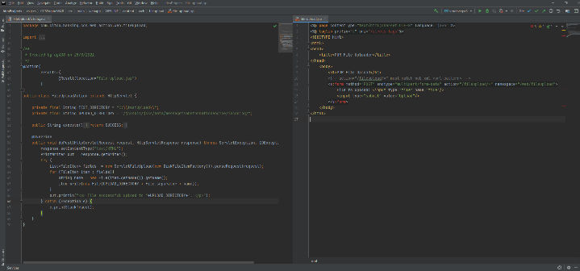

- Document Management System research: 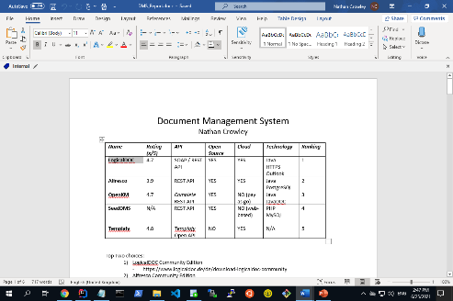

- Java JSP & Servlet JCCS: 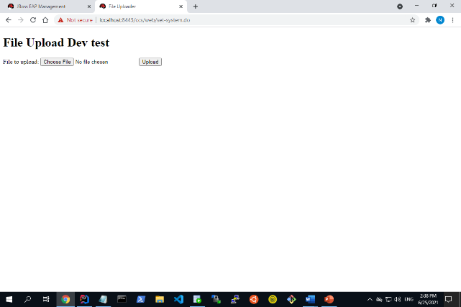

- JIRA ticket: 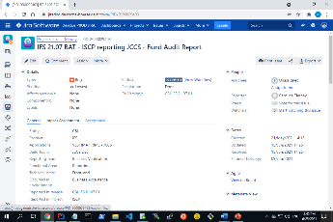

- SQL cutover example: 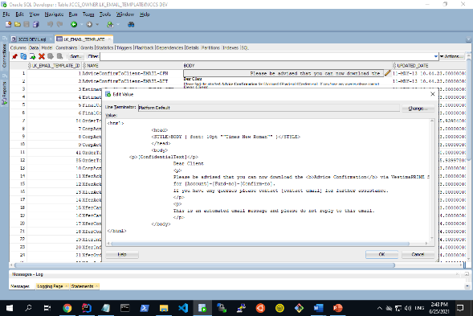

**References**

- <https://www.deutsche-boerse.com/dbg-en/investor-relations/financial-reports/annual-reports/annual-report-2019>.

- <https://www.clearstream.com/clearstream-en/about-clearstream>.

- <https://en.wikipedia.org/wiki/Clearstream>.